**Operation Analytics and Investigating Metric Spike**

*by Sneha Vora*

**Project Description:**

This project contains two case studies:

1) Operation Analytics

2) Investigating metric spike. Findings of case study:

* By analysing the data, the company finds the areas on which it must improve.
* Help other departments derive insights out of the collected data.
* Found the overall growth or decline of the company.
* Answer the questions asked by different departments.

**Approach:**

* **Both the projects are created using MySQL and MS Excel for visualisation.**
* **For case study 1 the table had to be created manually in the SQL workbench**
* **For case study 2, the given excel data had to be transferred to MySQL workbench to execute it and output is represented in charts using excel.**

**Tech Stack Used:**

* MySQL Workbench
* MS Excel
* MS Word

**Insights & Results**

***Case Study 1:*** *Operation Analytics*

* Created the Table: job_data

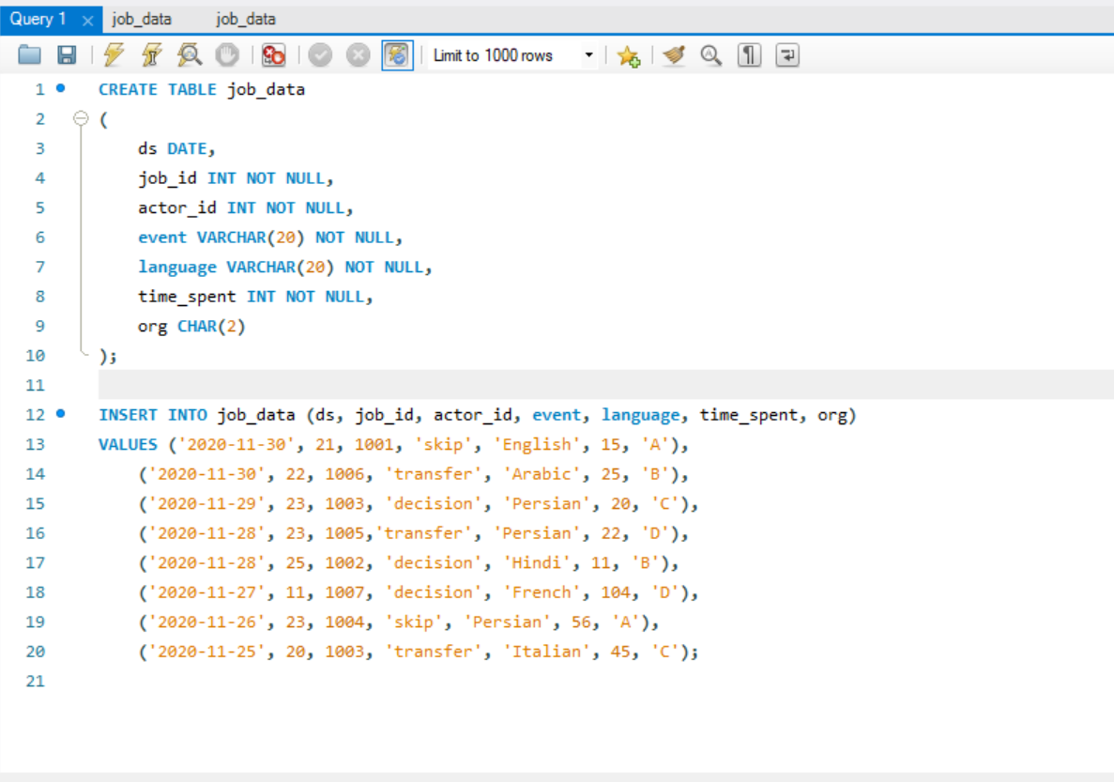 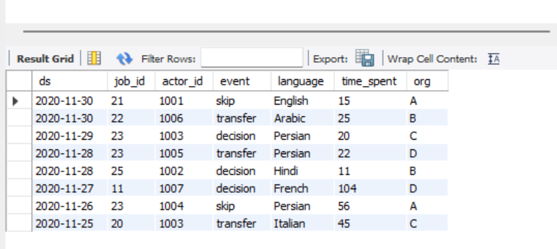

* **Calculate the number of jobs reviewed per hour per day for November 2020**

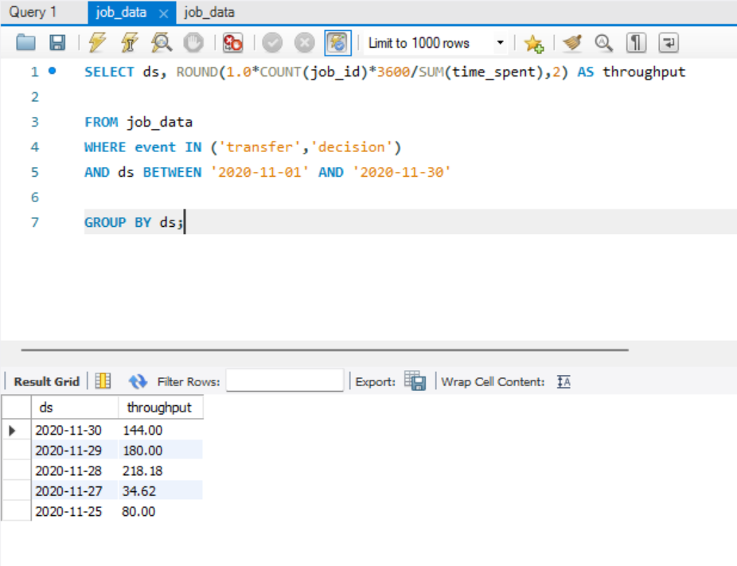

* **Let’s say the above metric is called throughput. Calculate 7 day rolling average of throughput? For throughput, do you prefer daily metric or 7-day rolling and why?**

**7-day rolling average is preferred because** It is a flexible method of measuring trends. If a few more figures are added to the data, the entire calculation are not changed, we only get some more trend values. Also, If the period of moving averages happens to coincide with the period of cyclical fluctuations in the data, such fluctuations are automatically eliminated.

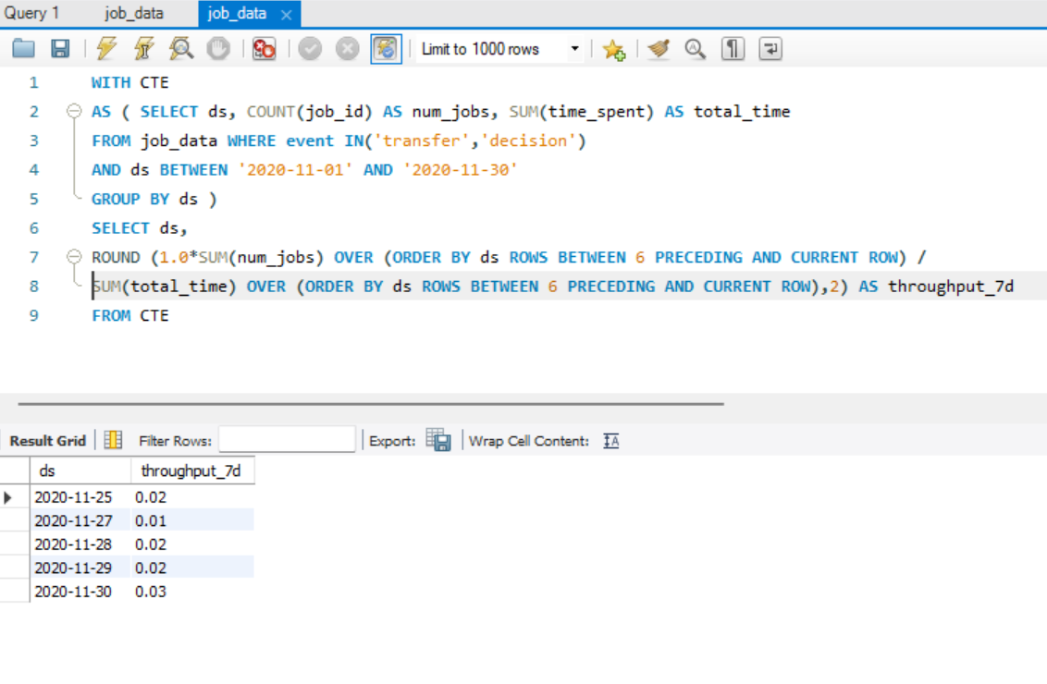

* **Calculate the percentage share of each language in the last 30 days?**

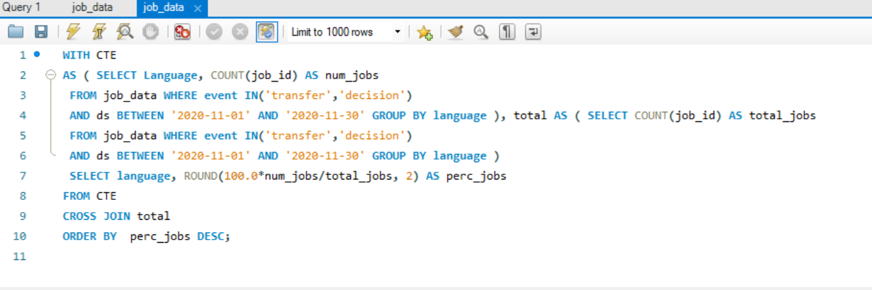

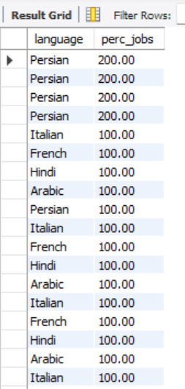

* **Let’s say you see some duplicate rows in the data. How will you display duplicates from the table?**

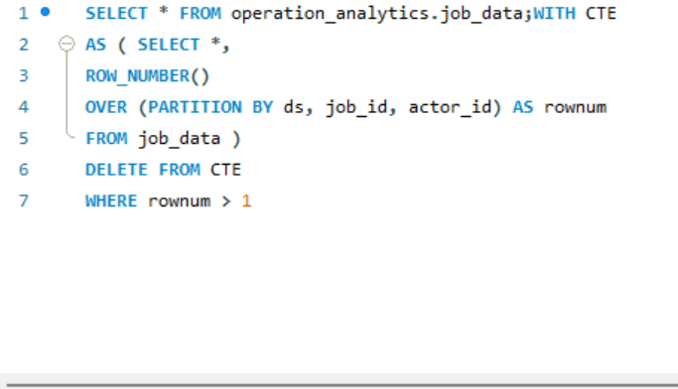

*Case Study 2: Investigating metric spike*

* 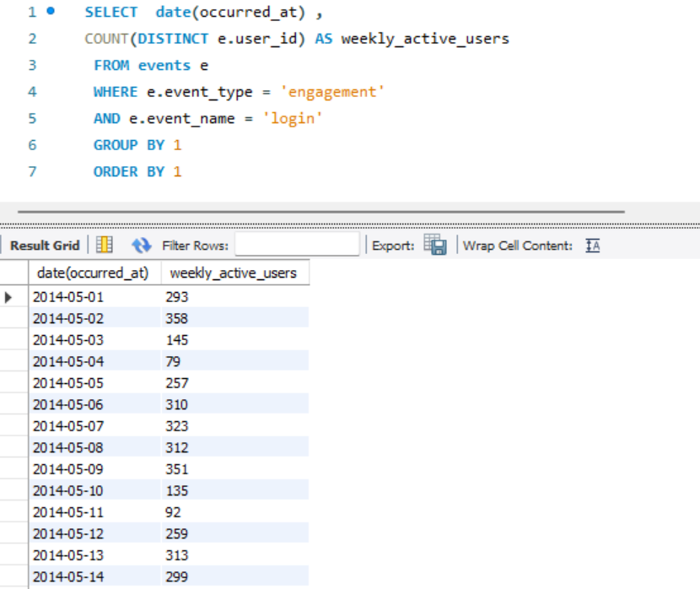Calculate the weekly user engagement?

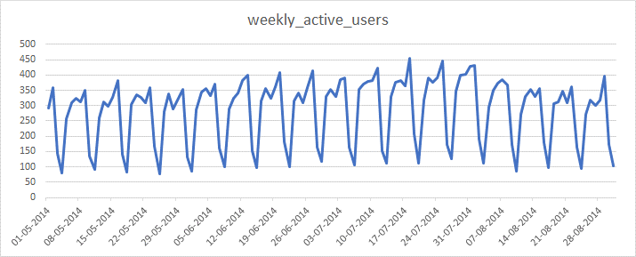

* Calculate the user growth for product?

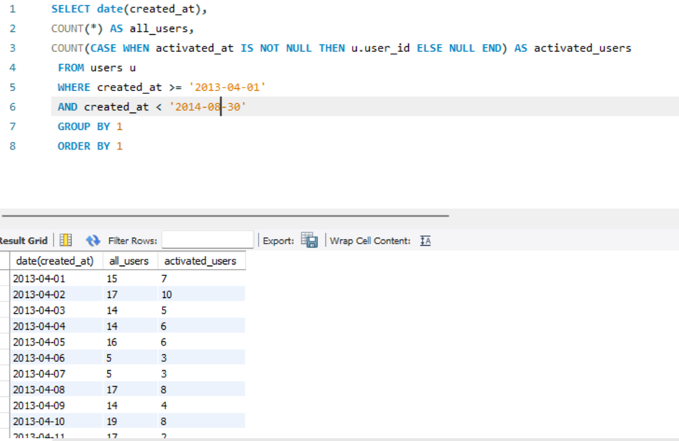

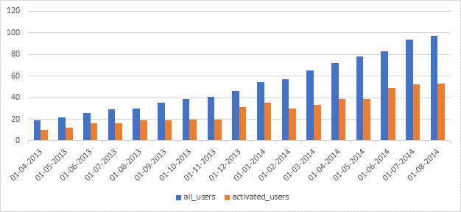

* **Calculate the weekly engagement per device?**

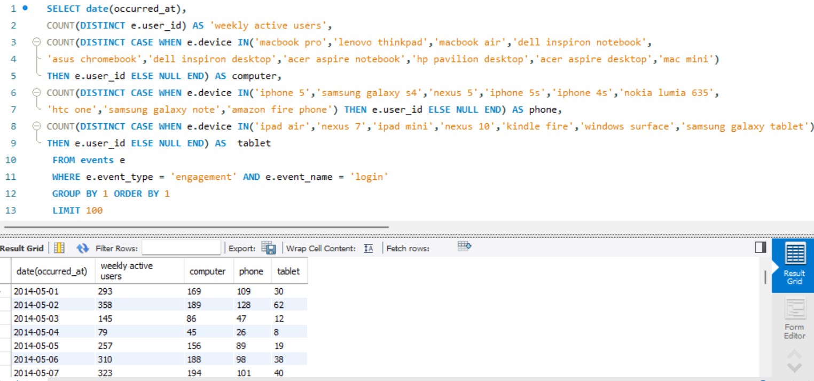

* Calculate the email engagement metrics?

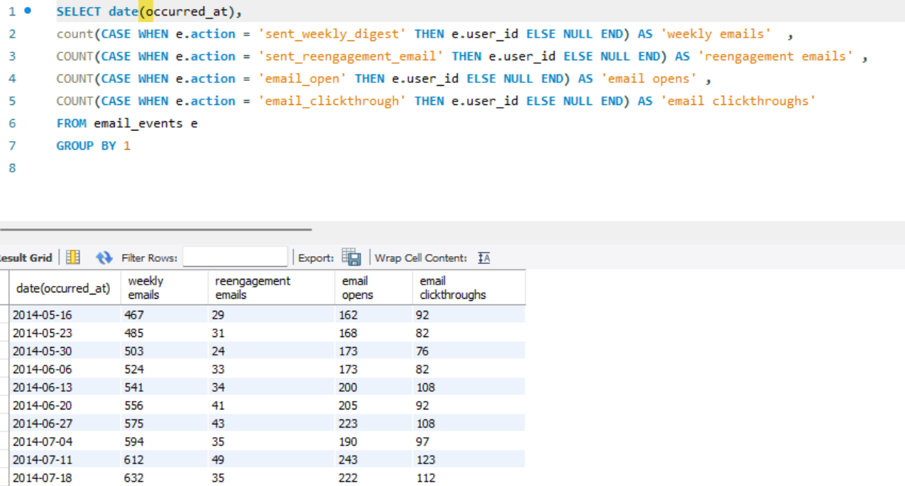

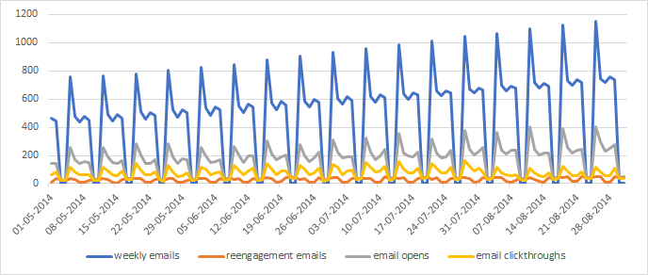

**Insights:**

* User engagement and email engagement metric both shower similar pattern for the period with consistent dips
* There was a growth of users for products over period of time.

**Results:**

* For case study 1 Operation analytics provided clear understanding of the job review process.
* For case study 2 Investigating metric spike provided understanding of weekly dips as there was a direct correlation with weekly active users.